AWS TASK -2

Step1:

Create the VPC using IGW using 256 public IP’s and 256 Private IP’s

Vpc I created like 192.168.0.0/16🡪 upto 65535 IP’s we can use

Screenshot mentioned below:

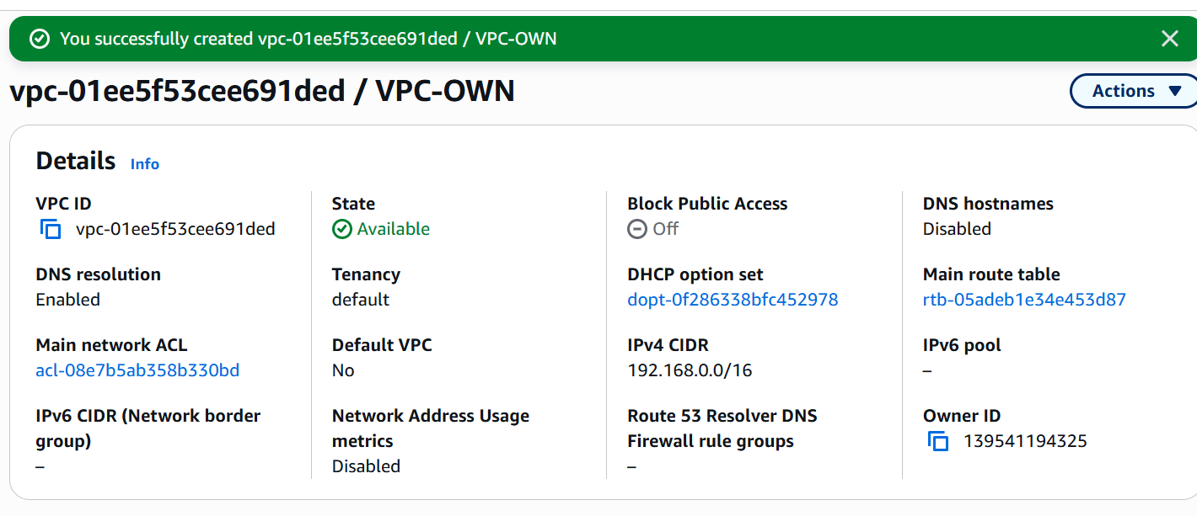

Step 2:

Next I gonna created for Public Subnet for 256IP’sand Private for 256 IP’s

Screenshot Mentioned Below:

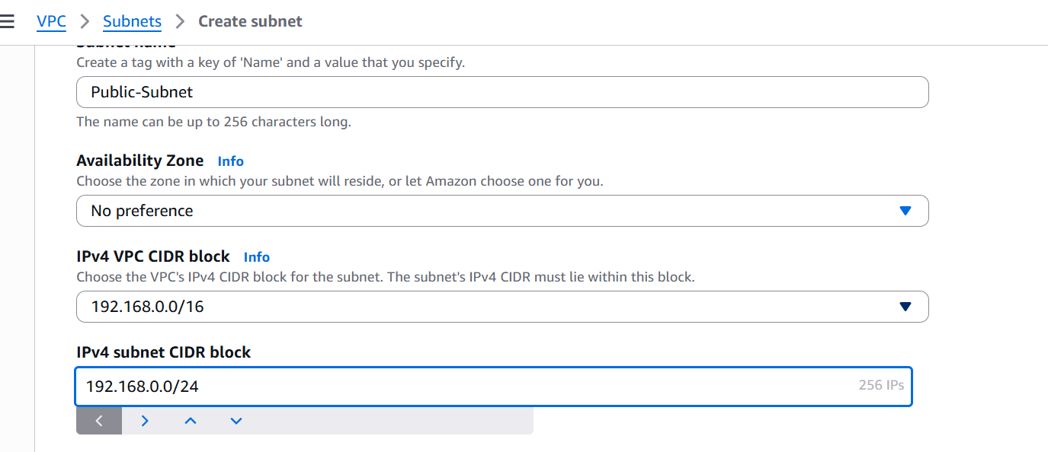

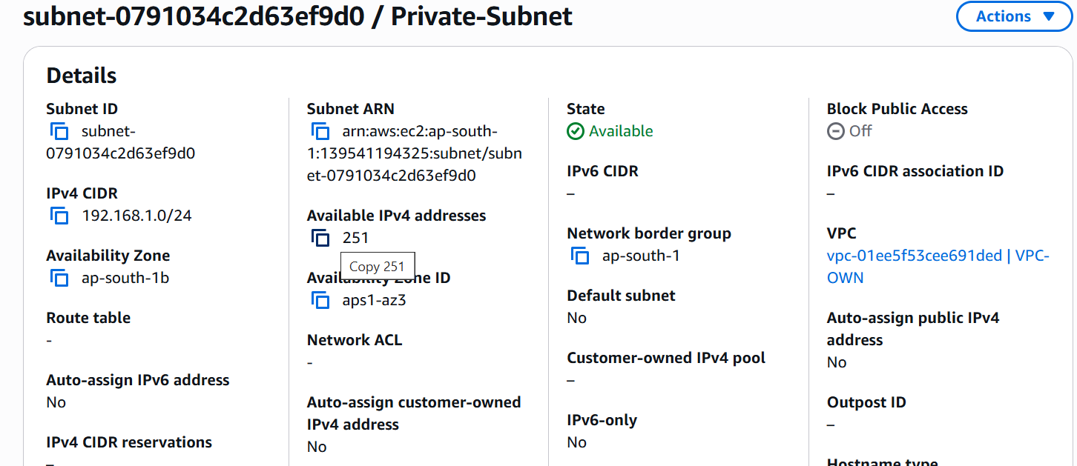

Step 3:

After Rote table and association of public and private also done then

Screenshot mentioned Below:

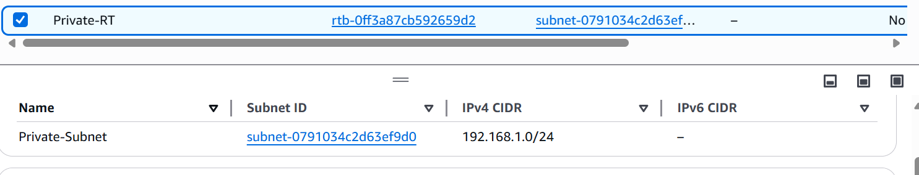

Step4:

Created the IGW and attached to our VPC

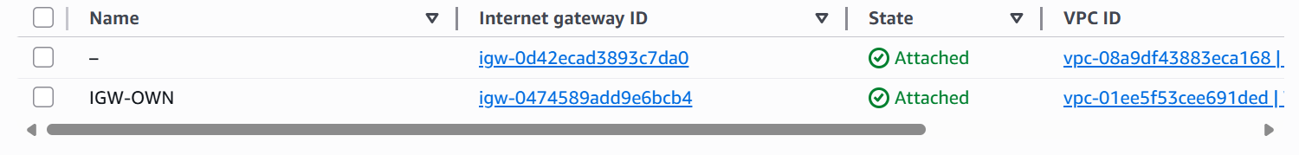

Step 5:

Creating the EC2 instance and connecting Through Our Own VPC

So inside the Network instance We gonna Choose the VPC and subnet We created and Trying to connect to our Ec2 wih own VPC its working

Screenshot mentioned below:

